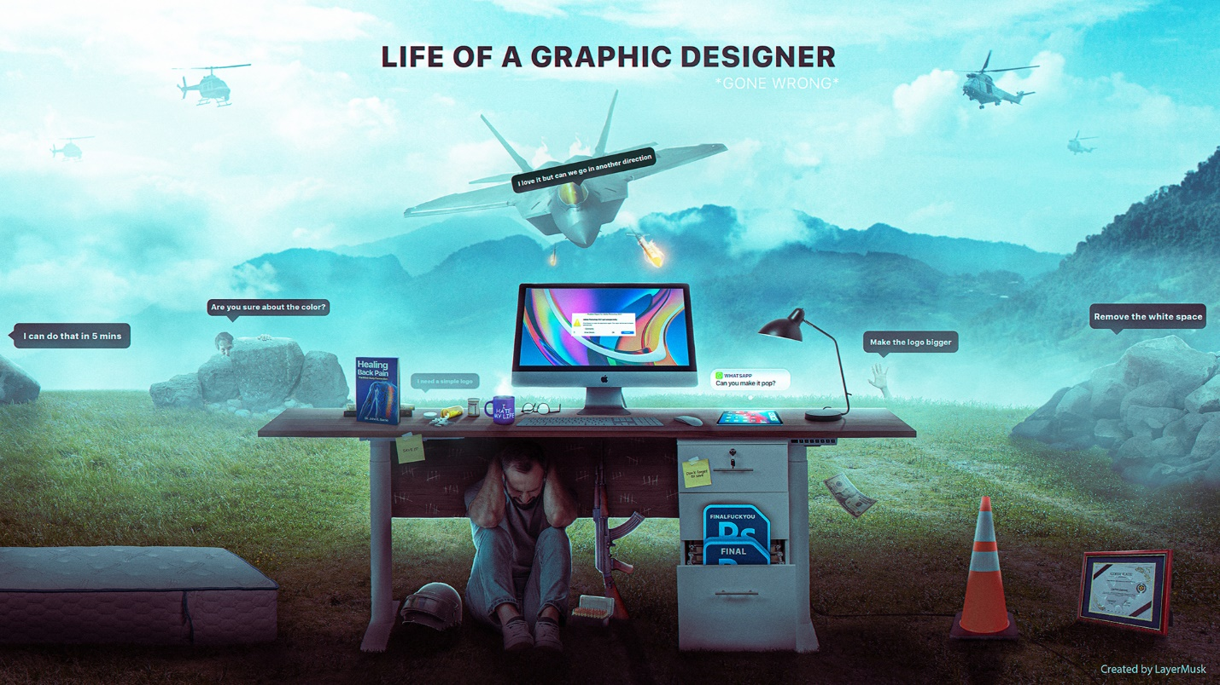

The life of a freelance graphic designer offers a unique blend of freedom and hustle. On one hand, you're the captain of your own creative ship, choosing the projects that pique your interest and setting your own schedule. Imagine waking up to a quiet morning, brewing a cup of coffee, and diving headfirst into a design challenge that truly excites you. No office politics, no rigid dress code – just pure creative exploration.

However, this autonomy comes with its own set of challenges. As a freelancer, you're responsible for everything from landing clients to managing finances and marketing your services. Imagine spending a frantic afternoon crafting the perfect proposal, only to receive radio silence from the potential client. Freelancers need to be self-motivated, juggling multiple projects at once while constantly drumming up new business.

But the rewards can be incredibly fulfilling. The success of your freelance journey hinges entirely on your skills, work ethic, and ability to build relationships. Imagine landing a dream project with a prestigious company, pouring your heart and soul into the design, and seeing your work used by a global audience. The sense of accomplishment and creative ownership is unmatched in the freelance world. It's a challenging path, but for those who thrive on independence and the freedom to define their success, freelance graphic design can be an incredibly rewarding career choice.